Lewis Arts Studio Program |  | Application Form
2019-2020 | Information, instructions, and application form for the Lewis Arts Studio program for middle school students.
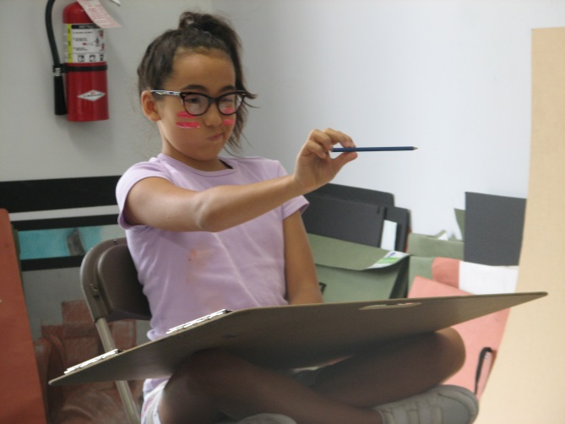
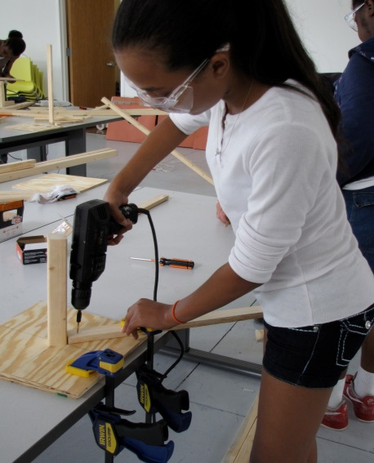
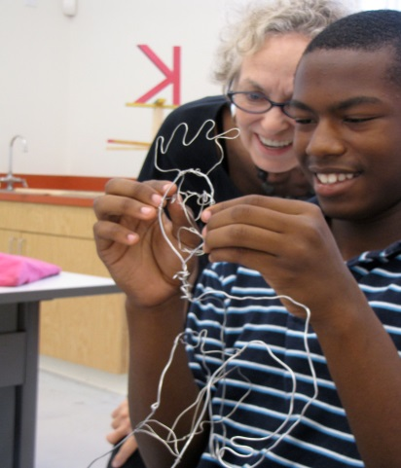
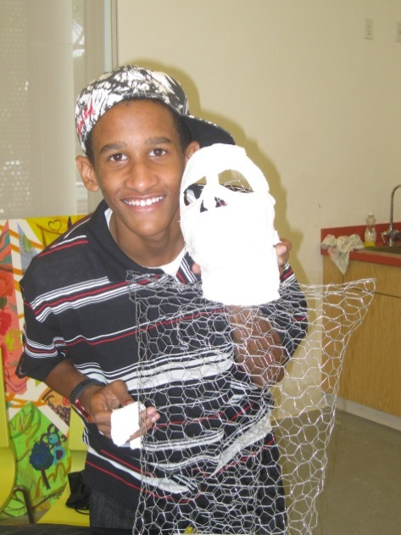
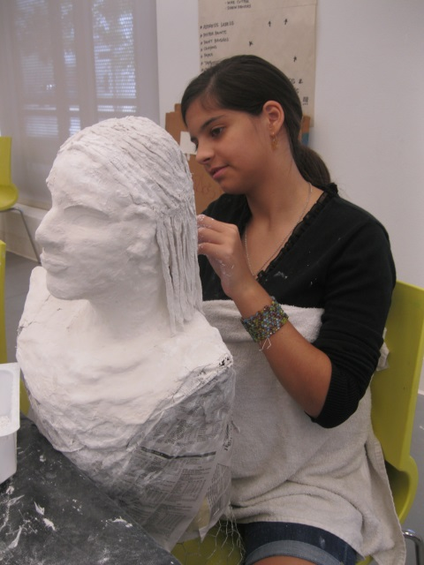
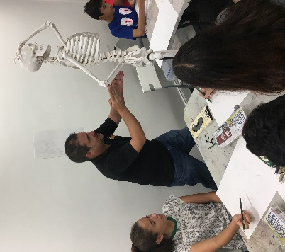
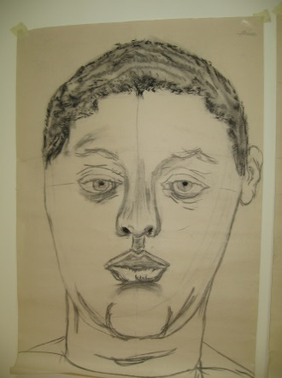
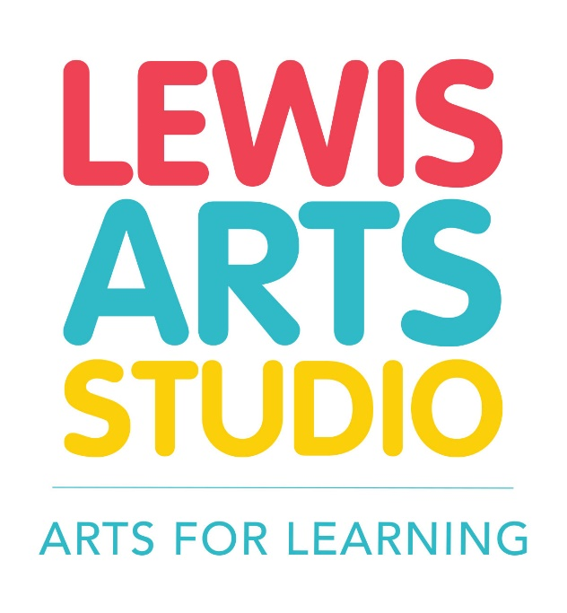

The Lewis Arts Studio (LAS) is a creative haven for middle school students who are interested in visual arts. It is a place where talent and friendships flourish; where curiosity and commitment is required; where portfolios are developed, but more importantly, where essential life skills are nurtured and practiced. At the Lewis Arts Studio commitment and interest in the arts is more important than a student’s prior formal art experience. Skills in teamwork, communication, critical thinking, problem solving and flexibility emerge as students become more sophisticated in their artistic craft and thinking.
The Lewis Arts Studio’s outstanding faculty of professional artists and art teachers help develop our students’ the technical and conceptual art skills. Our students also benefit from enriching arts experiences such as guest speakers, cultural excursions and exhibitions.

Lewis Arts Studio Program Includes Year-Round Activities
Student success and growth requires consistency, time and effort. That is why the Lewis Arts Studio is a year-round and multi-year program consisting of a summer intensive followed by bi-monthly Saturday sessions throughout the school year. Students may choose to remain in the program for more than one year.
Summer Four-Week Intensive: Includes instruction in visual arts skills and techniques with a focus on portfolio development; field trips to art galleries/collections and cultural destinations; guest artists and speakers; and a culminating student showcase.

DATES: Month of July, annually
Monday - Friday  9:30 am - 3:30 pm | LOCATION:  Lewis Arts Studio  101 Grand Avenue  Coral Gables, FL 33133
School Year Bi-Monthly Saturday Sessions: Continued instruction in visual arts skills and techniques with a focus on portfolio development; field trip, guest speakers and an informal student showcase. Support for application to arts magnet schools is provided to students who are interested.

Two Saturdays per month:  September - May, annually  9:30 am -12:30 pm | LOCATION:  Lewis Arts Studio  101 Grand Avenue  Coral Gables, FL 33133

APPLICATION REQUIREMENTS
Please submit the following required items:
- A completed application form (see Sections A & B on pages 3 & 4)
- Three (3) samples of observational drawings, specifically:
  - A self-portrait (from observation, using a mirror)
  - A drawing of a hand
  - A drawing of an object of your choice (i.e. shoe, plant, building, etc.)
Use pencil on 8.5” x 11” white paper. Label each drawing with your full name.
- A signed Letter of Commitment (see page 5)
- A teacher/counselor recommendation (see page 6)
- Students from families with an annual combined household income of $75,000 or less are given priority and may attend at no cost. Proof of income is required if annual combined household income is designated as $75,000 or less (see page 4). Attach your most recent tax return with your social security number blacked out.
- Applicant finalists are interviewed for final acceptance into the program (see below)
Mail or deliver your completed application packet by January 31, 2020 to:
Yazminda Merida-Acosta, Arts for Learning
404 NW 26 Street, Miami, FL 33127

All of the above requirements are used to determine placement in the program.
Incomplete applications will not be considered.
INTERVIEW FOR STUDENTS AND PARENTS/GUARDIAN
Interviews take place each spring in March, April and May. Arts for Learning staff will contact program finalists to schedule a 15 minute interview with the student and parent/guardian.
FEES
The Lewis Arts Studio is a free program for students whose families make a combined annual income of $75,000 or less. Families with a combined annual income over $75,000 may apply, but priority of admission is given to applicants with a combined annual income of $75,000 or less.

Mail or deliver your completed application packet by January 31, 2019 to
Yazminda Merida-Acosta, Arts for Learning, 404 NW 26th Street, Miami, FL 33127
Yazminda@A4Lmiami.org

APPLICATION FORM
SECTION A: Personal Information

(Please print or type clearly)

How Did You Hear About Us? __________________________ Referred by: __________________________

Student Name:________________________________________________________________________________________
First Middle Last

Address: ________________________________________________________________ Apt. Number: _______________

City: _____________________________ State: _____ Zip Code: __________ Home Phone: ______________________

Student Email: ____________________________________________ Cell Phone: ________________________

Current School: _____________________________________________________ Current Grade Level: _____

Gender: Male Female / Type of School:  Public Private Charter Magnet  Home School
Are arts classes offered at your school? Yes No
Do you live: 􀂉 With your parent(s) 􀂉 With relatives 􀂉 With non-relatives 􀂉 Other ________________
How many people (including yourself) live in your household? _______

#1 Parent /Guardian Name: ____________________________________ Daytime Phone(s): _______________

Address (if different from student): _____________________________________________ Apt. Number: ______

City: ______________________ State: _____ Zip Code: ___________ Home Phone: _____________________

Occupation: ___________________________________________ Email: ______________________________

#2 Parent /Guardian Name: __________________________________ Daytime Phone(s): _________________

Address (if different from student): _______________________________________ Apt. Number: ____________

City: ______________________ State: _____ Zip Code: ___________ Home Phone: _____________________

Occupation: ___________________________________________ Email: ______________________________

SECTION B: Demographic Information

Your answers to these questions are confidential.

Student Ethnicity:  Black Non-Hispanic  White Non-Hispanic Hispanic Haitian
 Asian/Pacific Islander  American Indian or Alaskan Native  Other ___________

Does The Applicant Have a Documented Disability? Yes No
If yes, check all that apply:
An Individualized Education Plan (IEP)
A Section 504 Plan
A medical diagnosis from a doctor
A diagnosis by a state certified/licensed professional (i.e. psychologist)
Disclosure by the parent or guardian describing the student’s specific condition and/or need for accommodations

If yes, how would you best classify the disability type(s)? (check all that apply):
􀂉 Autism Spectrum Disorders 􀂉 Chronic Medical Condition
􀂉 Developmental Delay 􀂉 Emotional/Behavioral Disorder
􀂉 Hearing Impairment (or deaf) 􀂉 Intellectual Disability (or MR)
􀂉 Learning Disability 􀂉 Physical Disability
􀂉 Speech/Language Impairment 􀂉 Visual Impairment (or blind)
􀂉 Other Disability______________

Language(s) Other Than English Spoken in the Home:
􀂉 Spanish 􀂉 Haitian-Creole 􀂉 Other __________________________ 􀂉 None

Public Assistance:
If anyone in your household has received federal, state, or local income-based public assistance within the past year,
check all that apply:
 Welfare   Food Stamps  Free or reduced school lunches  Unemployment benefits  Other
Household Income:
Please check the level of Family Annual Combined Household Income:
 $25,000- under  $25,001- $50,000  $50,001-$75,000  $75.001-$150,000  Over $150,000
Priority of admission is given to applicants whose families make a combined annual income of $75,000 or less; proof of income is required (see “APPLICATION REQUIREMENTS” page 2).

LETTER OF COMMITMENT
STUDENT STATEMENT OF INTENT
I understand that participation in the Lewis Arts Studio is an honor and that there is limited enrollment. Therefore, as a participant, I will commit to:
- Be present and on time everyday
- Complete all home learning assignments
- Commit fully to the program and give it my BEST
- Treat myself and others with respect
- Be open to new experiences and challenges

By signing my name below, I am letting you know that I understand the expectations you have for students accepted into the A4L Lewis Arts Studio. I also understand that this commitment lasts throughout the entire year of the program (summer and bi-monthly Saturdays throughout the school year), and for all the years that I participate in the program. I understand that failure to fulfill these expectations is grounds for dismissal.
_____________________________________________ __________________
Student’s Signature Date

PARENT STATEMENT OF INTENT
By signing my name below, I commit to supporting and encouraging my child for the duration of the A4L Lewis Arts Studio by:
- Avoiding to schedule activities that may conflict with participation
- Ensuring he/she attends regularly and punctually during the summer and Saturday bi-monthly sessions
- Ensuring he/she is picked up punctually at the end of each session
- Ensuring he/she completes home learning assignments
- Attending the Family Orientation
- Attending the Studio showcases

I understand that failure to fulfill these expectations is grounds for dismissal.
_____________________________________________ __________________
Parent’s Signature Date

RECOMMENDATION LETTER FROM TEACHER/COUNSELOR
Teacher/Counselor Name: ____________________________________________________

Position: ____________________________ School: _______________________________

Email/Phone: _______________________________________________________________
(We will only use this to invite you to our Showcase and/or to ask further questions.)

Name of Student Applicant: ___________________________________________________

How Do You Know the Applicant: ______________________________________________

In the space below, please tell us about this applicant’s motivation and passion, artistic skill, and other personal qualities that make them a strong candidate for this program. Indicate how the student would benefit from participating in the Lewis Arts Studio program. Feel free to attach an additional sheet or letter if needed.

Thank you for your assistance!

___________________________________________________________________________
___________________________________________________________________________
___________________________________________________________________________
___________________________________________________________________________
___________________________________________________________________________
___________________________________________________________________________
___________________________________________________________________________
___________________________________________________________________________
___________________________________________________________________________
___________________________________________________________________________

